What are the possible different outputs that can be produced with the following C code. Write down all possible outputs separately (make sure to take into account the probability that the fork() syscall will fail). Please explain your answer.

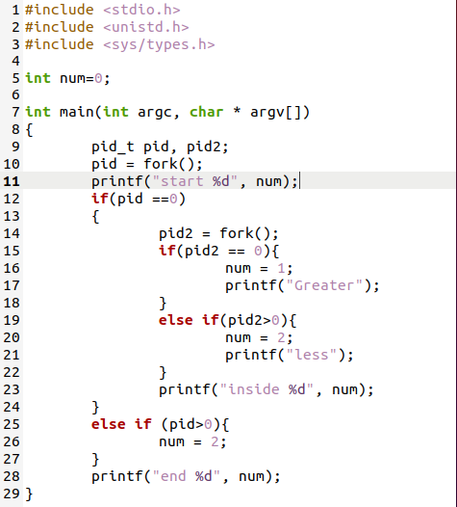

Answer:

There can be two situations, one in which new child process would be starts successfully and other situation is that in which child process would not be start.

First, we will suppose that, it would start new process.

Then the output would be **02 022011**

**First 0 is because at start of parent process value is 0.**

**And second 2 is because, As it is not a child process value will be 2**

**else if (pid > 0){**

**num =2 ;**

**}**

**will be run.**

**Third 0 is because at very start value of num is 0.**

**fourth 2 is because it is parent process,**

**else if(pid2>0) {**

**num =2;**

**}**

**Will execute.**

**Fifth 2 is because, value of num at the end will be print and it is 2**

**sixth 0 means that, child process will be start and at start value of num is 0.**

**seventh 1 means that it is child process**

**if(pid2==0) {**

**num =1;**

**}**

**will be execute and 1 will be printed.**

**eighth 0 is because it is end of that child process it will print 1.**

**Other Situation:**

In Second situation, we will suppose that, it would not new process.

In this situation no child process would be created. At that moment the value that would be print on the console as output will be **02.**

**As if one child is not created then other fork function would not be called.**